## Functional Requirements

**Guest (Not Logged In)**

Guest (not logged in) users with the functionality to login, register and **view** the Home page.

**Users (Logged In)**

**Users** (logged in) with the functionality to **view all the courses which are listed**, **course details page of all listed courses** and **they should be able to enroll in courses**. **Enrolled** **in** users should be able to see **lectures** in that course and the **Play Video** section. Courses can be **public** or **not.** Users can access **only** **public courses.**

**Database Models (10 Pts)**

The **Database** of the Tutorials application needs to support **2 entities**

### User

* Username - string (required), unique
* Password - string (required)
* **Enrolled Courses - a collection of** Courses

### Course

* **Title - string (required), unique**
* **Description - string (required), max length of 50 symbols,**
* **Image Url - string (required),**
* **Is Public - boolean, default - false,**
* **Created at – Date or String, required**
* **Users Enrolled - a collection of Users**

### Application Pages (70 Pts)

**Guest Pages (15 Pts)**

List the **top three (3) public courses ordered** by the **count** of enrolled in users in **descending** order.

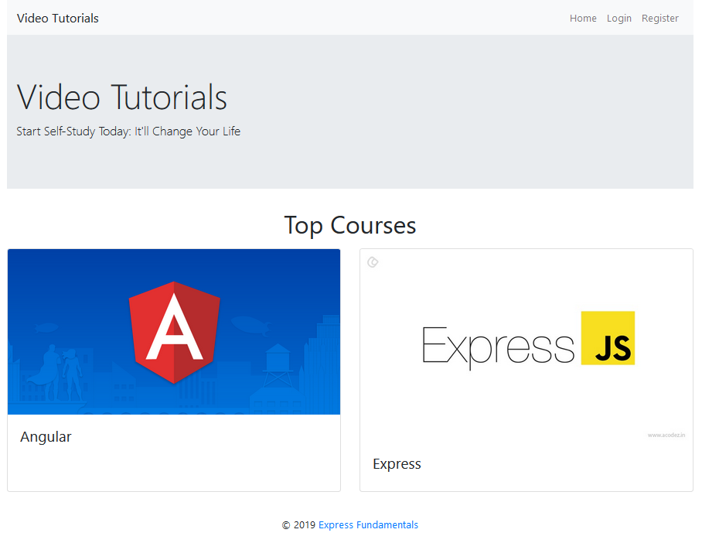

If there are no courses in the database yet, display **"No courses..."**

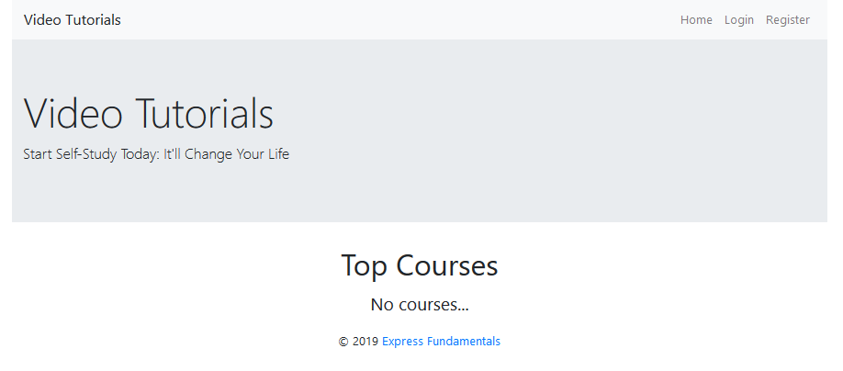

**Register Page (Logged Out User)**

Register a user inside the database with **username** and **password**. Both **passwords** must **match**!

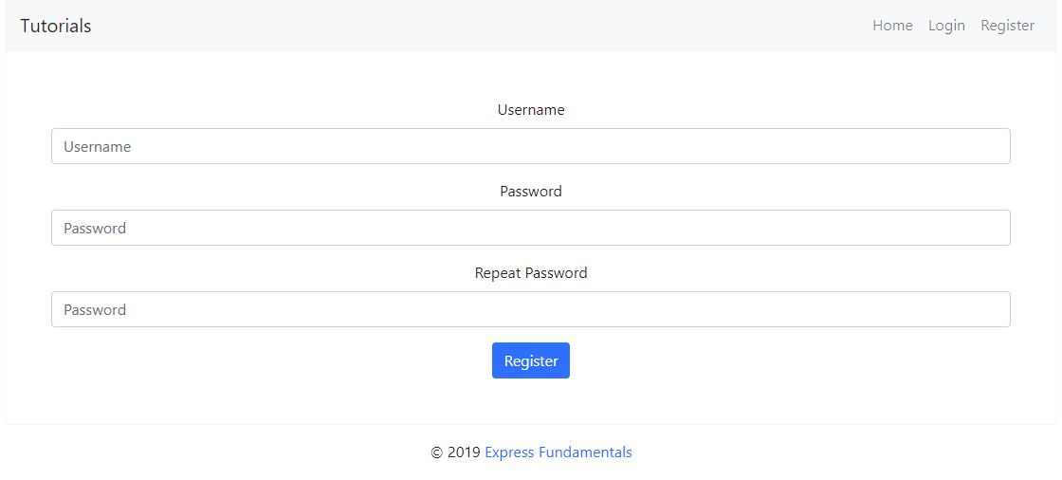

**Login Page (Logged Out User)**

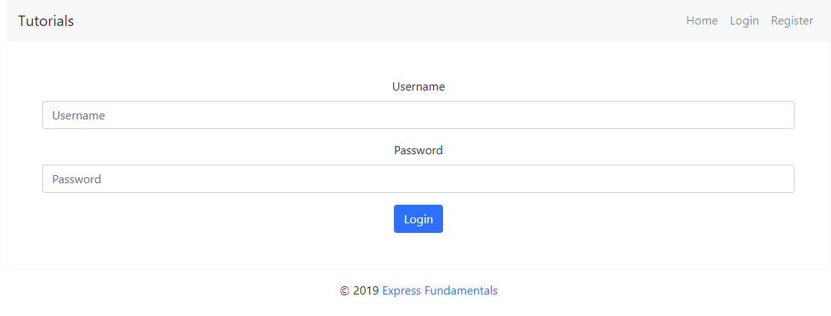

**User Pages (55 Pts)**

**Home Page (Logged in User)**

List **all public** courses sorted in **descending** **order** by the **created** **time** with a button **Details** which leads to a **course details page**.

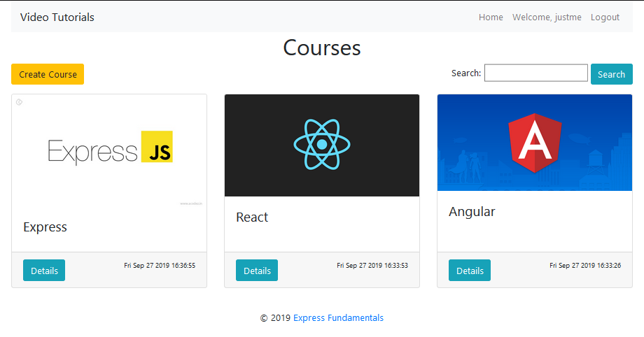

If there are no courses in the database yet, display **"No courses..."**

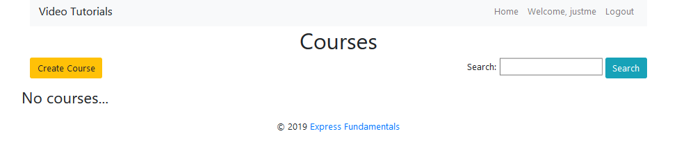

**Create Course Page (Logged in User)**

Enter course **title**, **description**, **image URL** and choose if the course will be **public** or not. You will receive the value of the checkbox as a string **"on"** if it's checked or **undefined** if it's not. You have to convert the received value as Boolean **true** or **false** and save the course in the database.

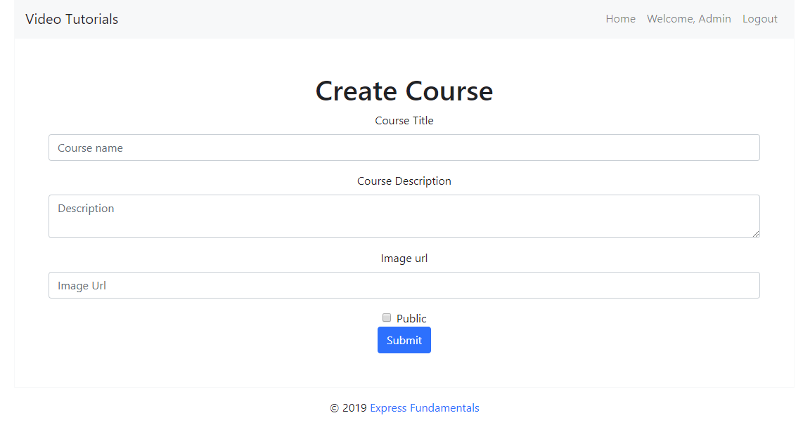

**Logged in Details Page (Logged in User)**

In the Details of a course section, you should load course **name** and **description**.

**Not Enrolled in Course (Logged in User)**

If the user is **not enrolled** in the course, you should display **Enroll button.**

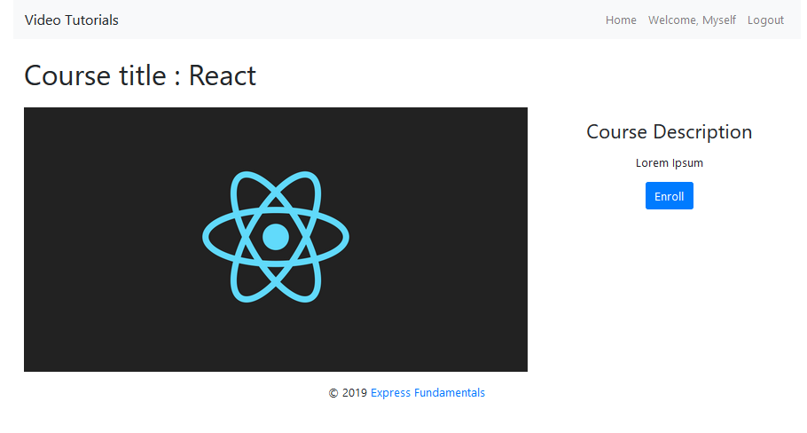

**Enrolled in Course (Logged in User)**

**After** the user has enrolled in the course, the **"You are already enrolled" span element** should be **shown instead of the [Enroll] button.**

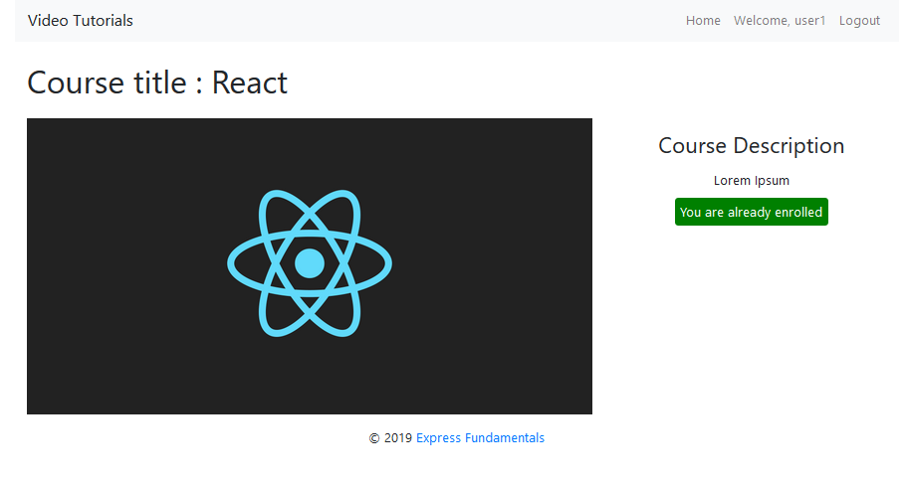

**Course Creator (Logged in User)**

The creator of the course should see **[Delete] [Edit]**

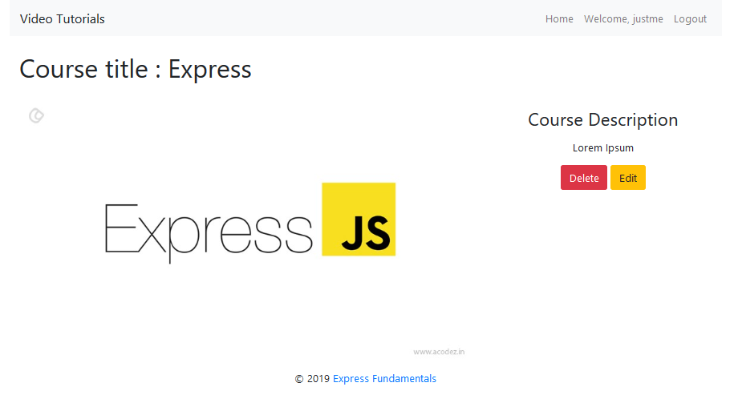

**Delete Course (Logged in User)**

Upon deleting a lecture (clicking over **[Delete] button**, you should be **redirected to the home page**.

**Edit Course (Logged in User)**

All form fields should be **filled** with the corresponding information of the selected course.

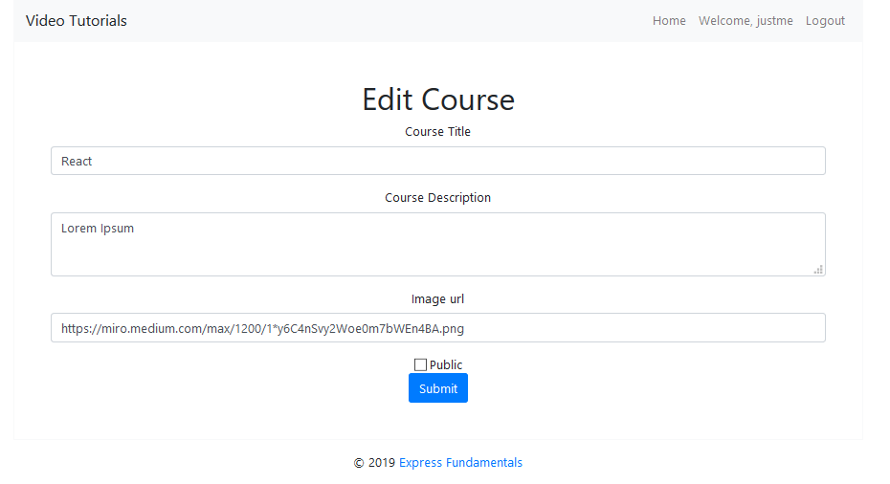

**Security Requirements (10 Pts)**

The Security Requirements are mainly **access** requirements. Configurations about which users can access specific functionalities and pages.

* Guest (not logged in) users can access Home page and functionality.
* Guest (not logged in) users can access Login page and functionality.
* Guest (not logged in) users can access Register page and functionality.
* Users (logged in) can access Home page (Listed all Courses)page and functionality.
* Users (logged in) can access **Course** Details page and functionality.
  + **Users** (not course creator) can **Enroll** **once** for the course
  + **Users** (course creator) can **Edit** and **Delete** the current course
* Users (logged in) can access **Create Course** page and functionality.
* Users (logged in) can access Logout functionality.

**Validation and Error Handling (10 Pts)**

The application should notify the users about result of their actions.

### Login / Register

You should make the following validations:

* The **username** should be **at least 5 characters** long and should consist only **english** **letters** and **digits**
* The **password** should be **at least 5 characters** long and should consist only **english** **letters** and **digits**
* The **repeat password** should be **equal to the password**

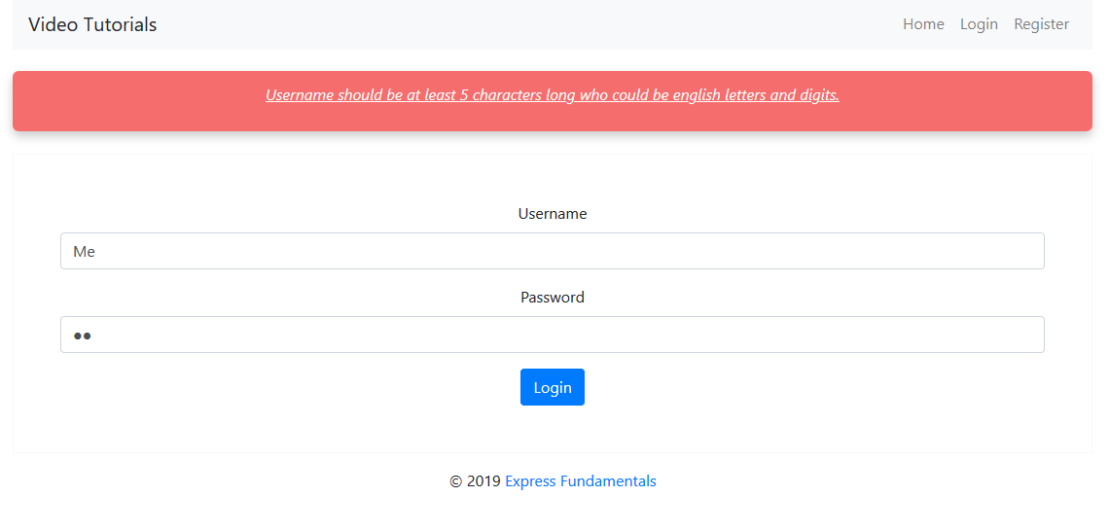

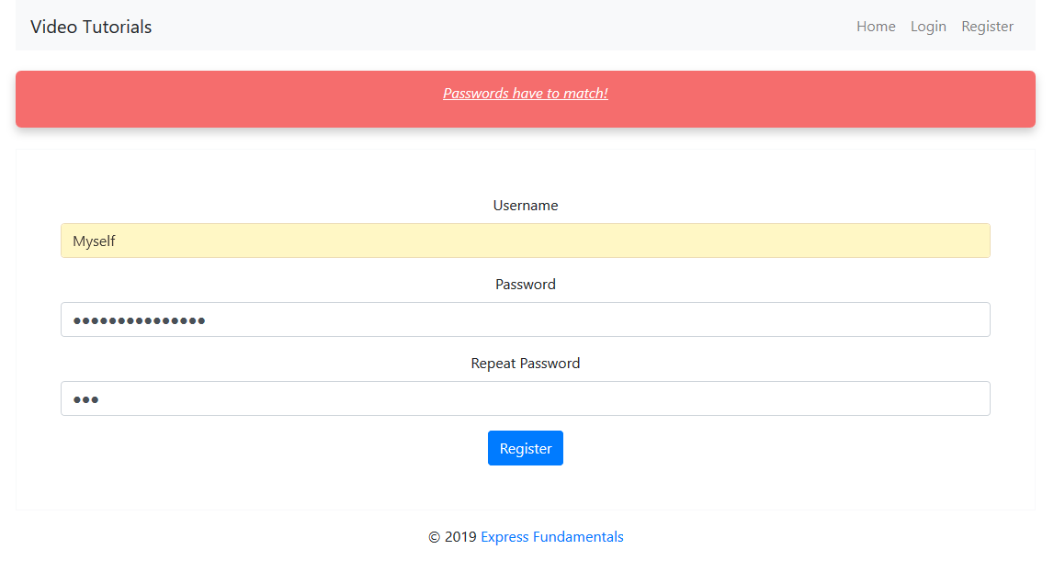

### Course

You should make the following validations while **creating** or **editing a** **course**:

* The **title** should be **at least 4 characters**
* The **description** should be **at least 20 characters** long
* The **imageUrl** should be **starts with http or https**

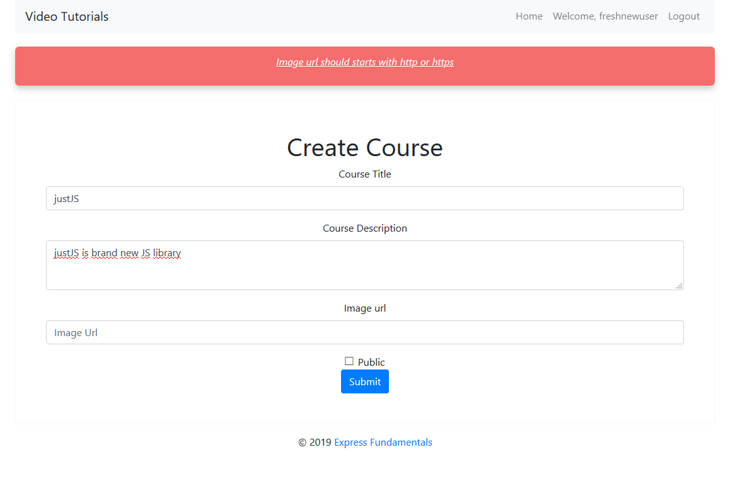

**\* Bonus (10 Pts)**

**Search in courses.** Filter only the **courses names** that **include the searched string** (**case-insensitive**).

